CHECKLIST FOR HOME:

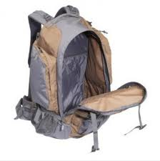
Unpack homework materials from book bag.

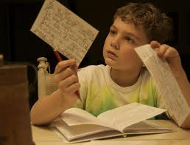
Do EACH assignment you wrote down in your homework book.


Have Dad/adult check your homework.
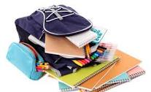
Put ALL homework back in your book bag.

